SAMPLE PAPER (2013)
CLASS – X
Subject:- Physics + Chemistry

Q.1 Choose the most appropriate option in the following question :
i) Which of the following statements is not applicable to compounds of carbon?
(a) They have low melting and boiling points
(b) They are ionic in nature
(c) They form a homologous series
(d) They are generally soluble in organic solvents

ii) Which of the following statements regarding the properties of graphite is incorrect?
(a) It is a non-metallic substance
(b) It does not conduct electricity
(c) It is used as a lubricant
(d) It is soft and slippery in touch

iii) Which of following is incorrect regarding bonding in carbon?
(a) It forms only covalent bonds
(b) It forms ionic as well as covalent bonds
(c) It can bond with other atoms of carbon to form long chains, branched chains and cyclic chain structures
(d) It shares all of its four valence e– for bonding to attain the noble gas configuration

iv) When a ray of light enters a glass slab from air
(a) Its wavelength decreases
(b) Its wavelength increases
(c) Its frequency increases
(4) Its frequency decreases

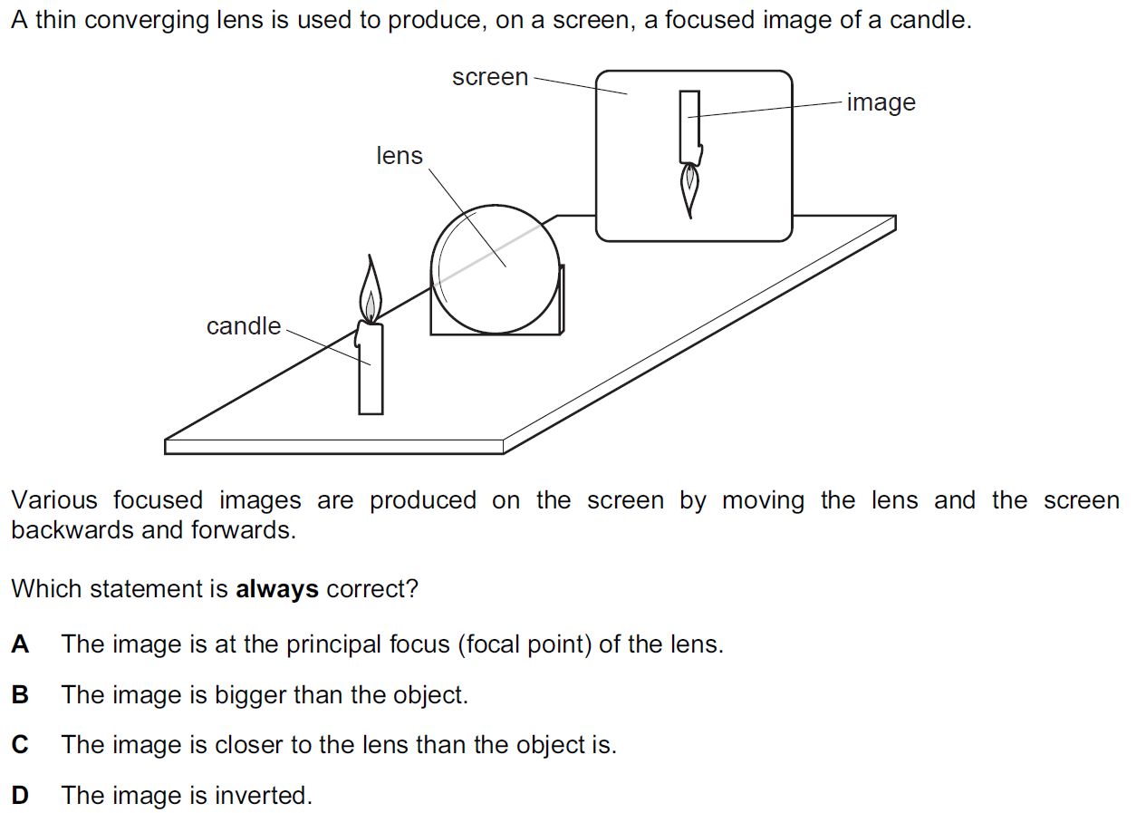
v )

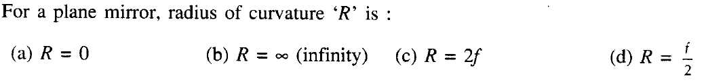
vi)

vii)

Q.2 If the value of linear magnification is +4 and size of the object is 5 cm. What is the nature and size of the image?
Q.3 How do you check whether the given mirror is a convex mirror?
Q.4 What is difference between a mirror and a glass plate?
Q.5 Name the gas which found in marshy area.
Q.6 A boy spreads a type of gas from a bottle to make his room full of fragenance, name the compound it is likely to be.
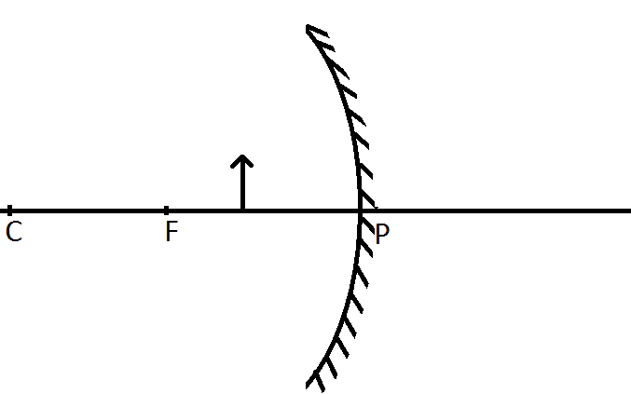
Q.7 Copy the diagram to your answer book and show the image formation.

Q.8 Write the formula and draw the structure of benzene.
Q.9 What is the SI unit of linear magnification?
Q.10 Define triple covalent bond and explain by an example.
Q.11 Write the functional group present in :
a) alcohol b) aldehyde

VATSALYA PUBLIC SCHOOL, MANDSAUR

